|  |  |  |
| --- | --- | --- |
| Qualification Code: | ICT60515 | |
| Qualification Title: | Advanced Diploma of Computer Systems Technology | |
| Unit Code/s: | ICTNWK607 | |
| Unit Title/s: | Design and implement wireless network security | |
| Student Id | Cal14385330 | Date : 30th of april. |
| Student Name | Benjamen Calleja | |
| Assessment Due Date: | As per Unit outline | |
| Assessment Name: |  | |
| Teacher’s name: | Murad Quazi | |
| Teacher’s email: | mquazi@kangan.edu.au | |

|  |
| --- |
| 1. Task Instructions |

This Assessment Item requires students to work individually and address all requirements as per Assessment item Description. Students are required to accomplish their task professionally and in time. Students must submit this Assessment at myKangan. This assessment item is practical task, open book and classroom based. Students are allowed to research on Internet. Allocated time for this assessment item is one hour.

|  |
| --- |
| 1. Submission instructions |

All items submitted must be clearly marked with the following details:

• Your full name

• Your student number

• Your class group

• The date

This cover sheet must accompany all items submitted.

By signing this document the student has read and accepted the Department’s assessment item submission policy as outlined in the ICT Student handbook and that:

1. The content of this assessment or assignment is my/our own work. Where the content is not original acknowledgments have been noted;
2. I/We have made a copy of any electronic, digitally prepared or paper based submissions as proof of completion.

|  |  |  |  |
| --- | --- | --- | --- |
| Student Signature: |  | Submission Date: |  |

# Marking Criteria

|  |  |
| --- | --- |
| **Grade** |  |
| NN | * Assessment aims have not been met |
| Pass 50 – 59%  CR 60-69%  DI 70-79%  HD 80-100% | * Student configured wireless network. * Student used IP Address scheme :192.168.1.1/24 and Default gateway : 192.168.1.1 * Student Mentioned router’s Make/Model * Student used security mode. * Student used Encryption methods |

|  |  |
| --- | --- |
| Comments: |  |

|  |  |  |  |
| --- | --- | --- | --- |
| Teachers Signature: |  | Date: |  |

|  |
| --- |
| 1. Assessment Item Description |

This assessment Item is Practical task. Marking Criteria for this assessment item is as per marking criteria. Students are required to configure the followings:

1. You are required to configure one wireless network using packet tracer.
2. You can use following IP Address scheme :192.168.1.1/24
   * Default gateway : 192.168.1.1
   * Mention your router Make/Model
3. Use security mode is preferably WPA Enterprise.
4. Encryption methods (Mention which one you used)

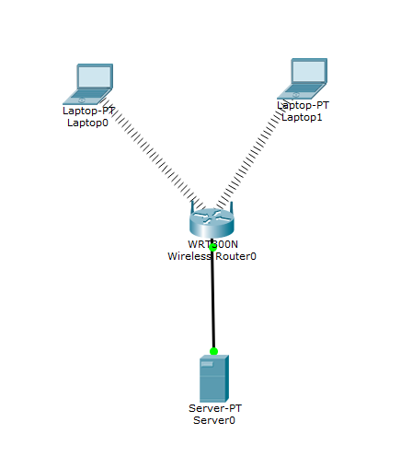



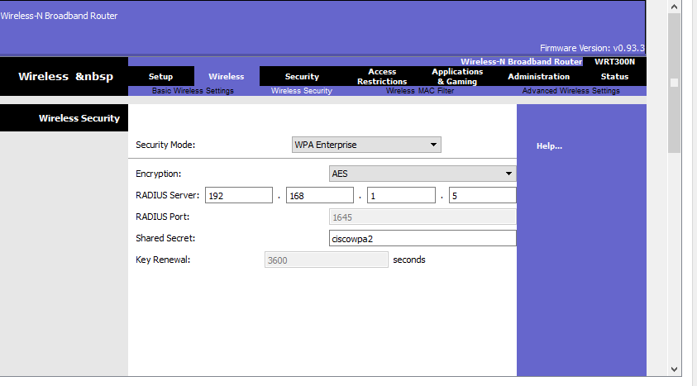

**The Encryption method I used was AES**